How do I apply for Project Choice?
You will need to complete an application form, recruitment usually takes place in June, when this starts, it will be advertised through information sessions, details of these will be sent to your school.

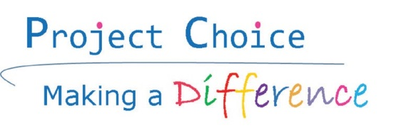
Health Education England
Supported Internships for 16-24 year olds with disabilities, learning disabilities, difficulties and/or Autism

What will I have to do to get a place on Project Choice?
You be invited to a group day which will include an interview, so we can get to know more about you.
This is so we know where you would be interested in working and what skills you have.

Where will I work?
The Project Choice team will ask some questions about where you would like to work and what your interests are. They will then match you to a placement you will enjoy.

Will I get paid?
Project Choice is an internship and an education programme; you will not be paid.
You may be eligible for a bursary which you will be able to apply for once you have a place on the project.
This will mean you will have some money to help with travel and food.

For further information about Project Choice contact:
Clare Coyne
Clare.Coyne@sth.nhs.uk
0114 27 14985
OR
Rachel Baston
Rachel.Baston@sth.nhs.uk
0114 30 52959

Project Choice - 2017

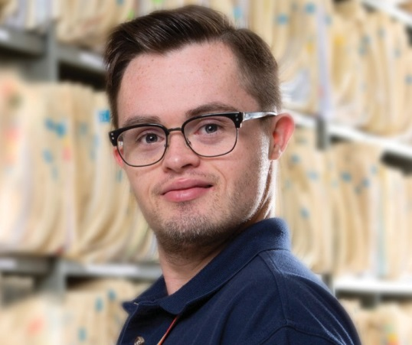

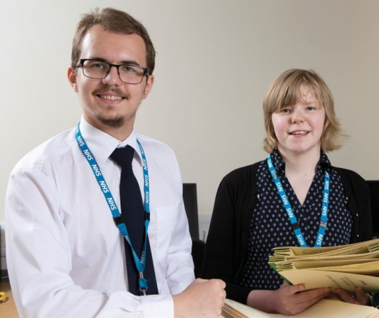

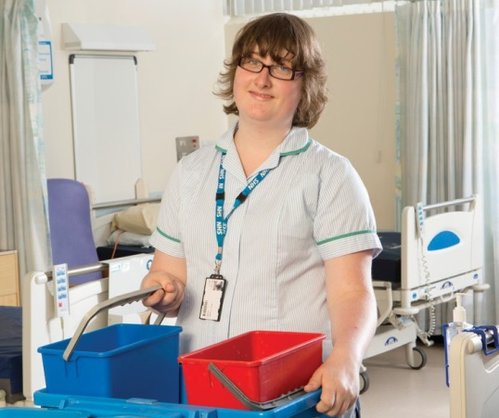
Places now available in Sheffield Teaching Hospitals and the surrounding community.
Are you ready to work but need support to do so?

Would you like to increase your confidence and improve your self-esteem while meeting new people and gaining confidence?
Then Project Choice could be for you!
What the project includes

The programme runs for 1 school year (September to July) and is term time only.

You will be offered up to 3 placements throughout the year running, these are each 10-12 weeks long.

Each week you will spend 4 days in your work placement and 1 day in the classroom.

In the classroom you will learn about work and developing work skills and also study towards improving your maths and English.

You will be supported by a workplace mentor, project coordinator and a project manager.

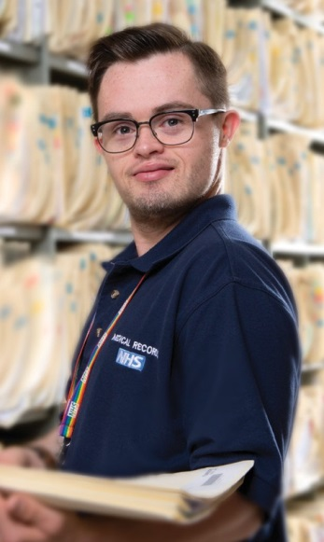
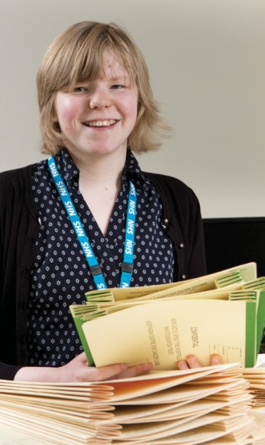
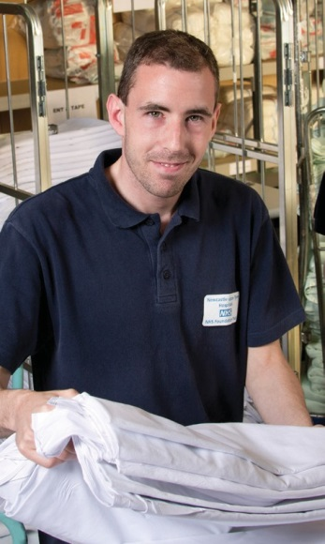
I enjoyed the sense of responsibility, being in a new
environment and meeting new people”
Project Choice has made me have hope and also it gave me
an idea of what I want to do when I leave the course.”

Project Choice is a programme that helps young adults gain work experience and improve employability and independence skills.
We provide internships within healthcare settings and other NHS partner organisations in supported environments getting you ready for the working world.
Our support is tailored to each person and we match employment options to each person’s skills.

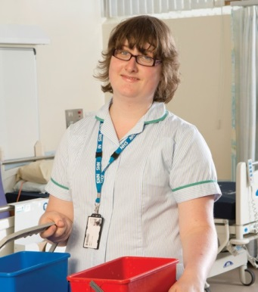
“I feel like an adult. I have travelled to work in-dependently, done my job and travelled
home independently - just like other workers. I’m so proud of myself, I want to keep working”

