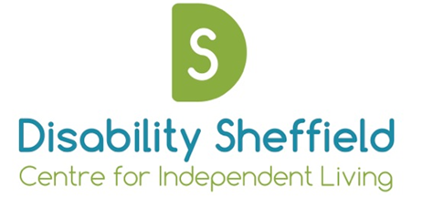

Disability Sheffield Centre for Independent Living
Annual General Meeting

Notice is hereby given that an Annual General Meeting will be held

On: Friday 19th November at 2.45 – 3.30pm

At: Virtually via Zoom Meetings
To register email: Emily.morton@disabilitysheffield.org.uk

Agenda

- Opening Remarks – Darren Lee, Chair

- Apologies

- Approval of 2020 AGM minutes

- Appointment of trustees

- Presentation of 2020/21 Accounts and appointment of independent examiner

- Brief Overview of Year – Emily Morton, Chief Executive

- Closing Remarks – Darren Lee, Chair

