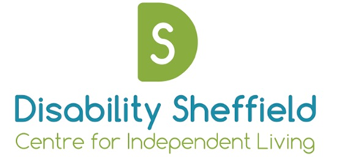

Disability Sheffield Centre for Independent Living
Annual General Meeting

Notice is hereby given that an Annual General Meeting will be held

On: Friday 4th December at 1.30 - 2pm

At: Virtually via Zoom Meetings
To register & meeting link email: Emily.morton@disabilitysheffield.org.uk

Agenda

- Opening Remarks – Darren Lee, Chair

- Apologies

- Approval of 2019 AGM minutes

- Appointment of trustees

- Presentation of 2019/20 Accounts and appointment of independent examiner

- Brief overview of year – Emily Morton, Chief Executive

- Closing Remarks – Darren Lee, Chair

