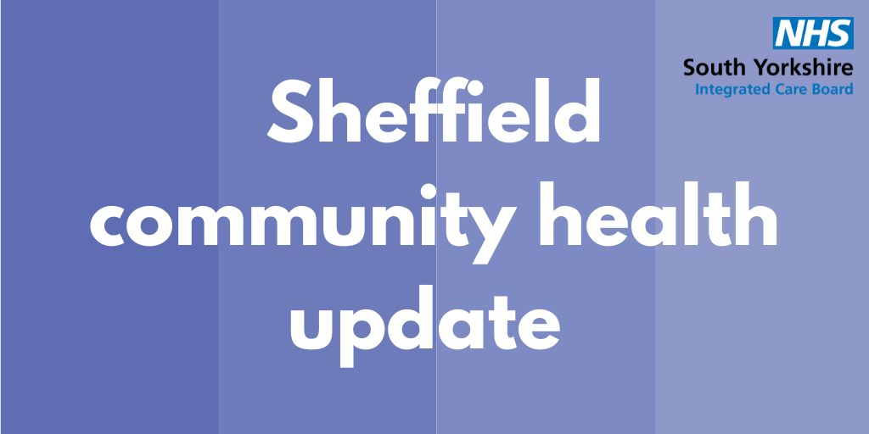

4 November 2022
Covid-19 update
If you don’t already know, the NHS has been inviting people for their covid booster this autumn. It will be offered to those most at risk of getting seriously ill from covid-19 first. If you’re aged 50+, or at higher risk, you can book online now.

The autumn booster targets and protects against both the original virus and the Omicron variant. The covid booster will reduce the chance of you becoming severely unwell from the virus.

It’s easier than ever to get your autumn covid booster. They are available at 32 different clinics across Sheffield, so there should be a site near you. Take a look here.

It’s also important to note that where they have supplies of both covid vaccines, your GP will vaccinate you with both the flu vaccine and covid-19 booster at the same time but if you’re invited separately, it’s important you attend both appointments.

As the number of covid infections increases over autumn, the covid booster and flu jab will help to reduce your risk of being seriously ill or being admitted to hospital.

Flu update
Flu is serious and is different to the common cold. The free flu vaccination is offered to those who are at increased risk from the effects of flu.
These include people aged 65 and over, pregnant women, those with certain underlying health conditions, health and social care workers, children aged 2-3 years old and all primary school aged children who will be offered the nasal spray vaccine at school. You will be contacted by the NHS if you are eligible for vaccination.

Everyone aged 50 – 64 is also able to get a free flu vaccination this year. If you are in this age group, don’t wait to be invited by your GP, you can get your vaccine from your local pharmacy.
Symptoms of flu include a high temperature, body aches and fatigue. If you think you have flu stay at home and rest until you feel better. Call NHS 111 if you have an underlying health condition or feel unwell.

For most children, the flu vaccine is not an injection, just a quick nasal spray. Flu can be horrible for young children, so it is important to protect them from becoming unwell.

The flu and covid vaccinations protect you from two different viruses so it is important to have both if offered. Where possible you will be offered both vaccines at the same time, depending on stock of the vaccines. If you’re offered two separate appointments, it’s important to attend both.

If you’re eligible for a free flu vaccination but haven’t had yours yet, speak to you GP or pharmacist as soon as possible. The vaccination will still be effective.

Updates on the primary care capital estates consultation
NHS South Yorkshire ran a public consultation on behalf of local GPs on proposals to relocate nine GP practices to four new health centres in Sheffield. The consultation ran for 10 weeks between 1 August 2022 and 9 October 2022.

We received contributions from 4,917 people through the various different feedback methods.

We want to thank you all for your contributions throughout these consultations. The feedback from you has been vital in our decision-making. The high number of responses gives us confidence that the feedback we have received reflects the overall views of the wider affected population.

GP practices and the programme team are currently considering the consultation findings and these will be used to inform the final decision. The consultation findings will be presented at the NHS South Yorkshire Board on 4 January 2022.

Cost-of-living crisis support
The effects of the cost-of-living crisis are being felt across Sheffield and it’s easy to feel overwhelmed and anxious about the winter months.

Sheffield City Council has designed a two-sided postcard specifically for frontline workers (anyone who has a public-facing role in an information and support environment or remit) to use to sign-post people to the relevant groups who can offer support and advice.

You can access information by scanning the QR code, by opening your camera on your phone – it will automatically take you to the information hosted in the link.

QR codes will give you a large amount of support information in one easy to access link to PDFs and websites without having to type in or remember a web address:
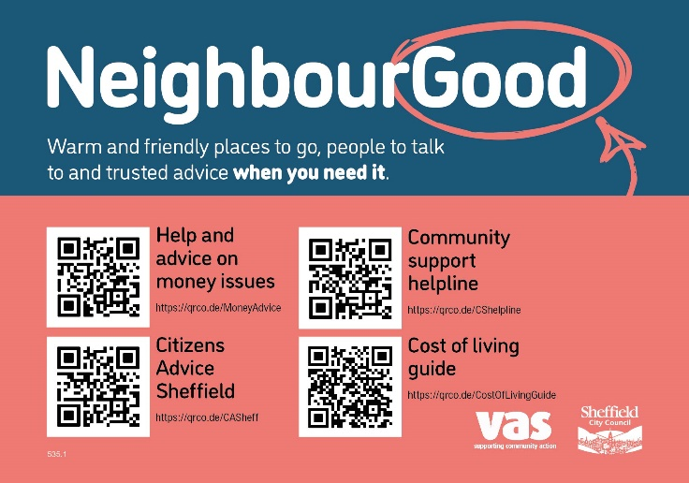
The organisations and information listed on the postcards are there to provide quick direct support information where and when needed if people are worried about finance, energy, meals and more.
It also includes a live list of hosts offering warm and friendly places, people to talk to and trusted advice.

If you need more help on using this or require more printed copies, please email emma.taylor@sheffield.gov.uk or call 07787 148 156.

