New Carers Outreach Group
part of Sheffield Mencap & Gateway’s Carers Outreach Project (COPe)
Meeting every first Tuesday of the month

Tuesday 1st October 11 am to 2pm
Meet at Birley Golf Course, 7 Birley Lane, Sheffield S12 3BP or the Fairway Inn, Birley
Wood, S12 3BP. You are welcome to join in with all the activities or just the golf or a meal.·

Golf lesson at Birley Golf Course 11 – 12.15pm
·Meal at the Fairways Pub 12.30 – 2pm

Tuesday 5th November 11am to 2pm
Meet at Birley Moor Fire Station, Community Room, Moor Valley, Sheffield, S20 5FA
·
Tour of fire station and advice session lead by fire officer about keeping safe during winter
·‘Festivals of Light’: create your own lantern and artwork around light festivals
·Try a variety of different foods around celebrations of light
·Potluck Buffet or pub meal
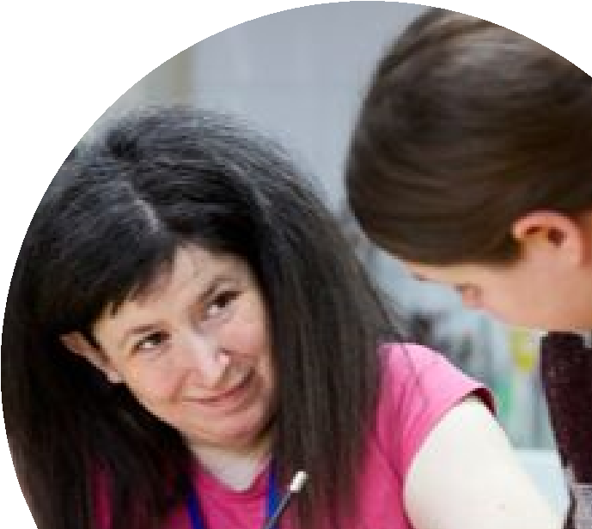
Tuesday 3rd December 11am to 2pm
Meet at Birley Fire Station
·
Make festive decorations and cards
·Games
·Potluck Festive Buffet or pub meal

Additional charges may apply

There is limited parking at the Fire station, spaces are available on a booking basis if there are mobility needs, alternatively there is parking nearby. Parking available at the Fairway Inn and golf course. If you need guidance with transport the COPe team can help plan the journey with you, just get in touch on the details below.

The group will continue and grow in 2020, dates and times to be agreed.

Contact the team
For more information contact the COPe Team 0114 2758879
cope@sheffieldmencap.org.uk

