Application form

Thinking about health and
people with learning disabilities
20th September 2018
at Showroom and Workstation,
15 Paternoster Row, Sheffield, S1 2BX

Please complete a separate application for each person

 | Your name | ------------------------------------------------------------

Tell us the best way to contact you
 | Email | ------------------------------------------------------------
 | Telephone | ------------------------------------------------------------

All information that we give out will be in easy read format.
Please tell us if we need to be aware of any specific needs that you have to help you take part in the day.
This might be accessibility or mobility requirements, sight/hearing issues, reading/writing or dietary preferences for lunches during the training.

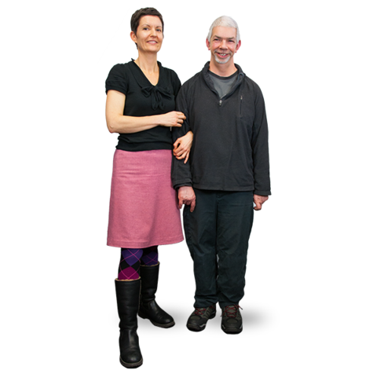 | Please tell us if you are coming with a supporter | YES / NO

Thank you for your application.

If possible, please send your completed form as an email attachment to meetingsandevents@ndti.org.uk

or send to:
National Development Team for Inclusion
First Floor,
30-32 Westgate Buildings,
Bath BA1 1EF

Tel: 01225 789135

If you send us a completed application form and a place is reserved for you, please let us know if you cannot attend so that we can offer your place to someone else

