Developing the NHS England Forum for People with Learning Disabilities and/or Autism, their Families, Carers and Supporters
Thank you to everyone who came to the first meeting about the ‘Forum’ on June 16th at NHS England in London. We hope you found it interesting and helpful.
This meeting was to talk about developing a national learning disability network. It will help NHS England hear the voices of people with learning disabilities and the people and organisations that support them. The network will build on existing networks of support to connect people with learning disabilities, autism, families and carers to ensure that their expertise is used improve the experiences and outcomes of people with learning disabilities.
You told us that feedback was important so we are telling you what we heard on the day. You helped us answer three questions about how we want to work:
- Who should be involved?
- How should our network work?
- What might the challenges be?
We have put your suggestions into groups of similar ideas. We have used these ideas to create our ‘next steps’.
The new NHS England Learning Disability Engagement Team will build on existing networks. We want to make sure that everyone’s experience and expertise is used. We want to develop person-centred, responsive and high quality services and support. If you have any suggestions or questions about the work we are doing, you can contact us by emailing LDengage@nhs.net or phoning 0113 825 0861.
We look forward to working with you.

Who should be involved?
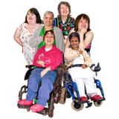  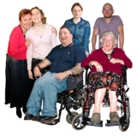 | - People with learning disabilities  - People in Learning Disability Services  - Quality checkers  - Experts by experience  - People with lived experience  - Severe disabilities and complex needs  - Don’t forget adults with Autism!
- Young people with Learning Disabilities

- Don’t ignore young people!
- Involve carers but let young person speak
- Children
- Families

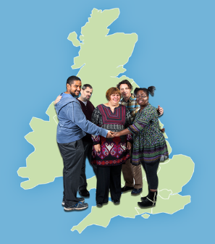 | - Existing Learning Disability Networks  - Regional networks  - Two people per region  - Local networks  - Positive Behaviour Support Network  - Learning disability nurse networks
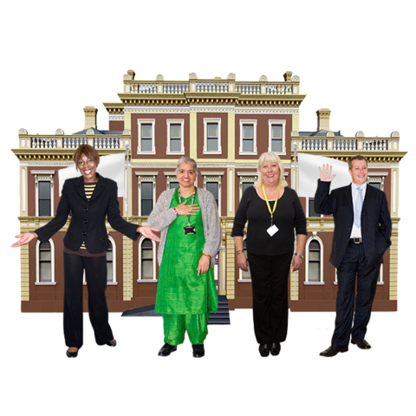 | - Voluntary and community groups  There are lots of voluntary groups we need to involve. Here are some specific examples you mentioned:  - National Valuing Families Forum  - National Autistic Society  - Mencap  - Challenging Behaviour Foundation  - Healthwatch
- Decision Makers
- Local commissioners
- Local partnership boards
- NHS, Department of Health, Care Quality Commission, social care come together for joint agenda and programme

How should our network work?

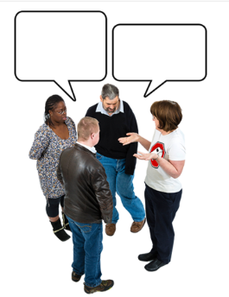 | - Everyone can talk to each other  - Top of the tree needs to quickly connect with the bottom  - Policy makers, decision makers, clinicians and people using services can communicate directly with and support each other  - Link up the networks  - A group of people who can instantly provide feedback
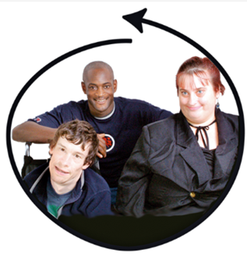 | - Involve people on all levels  - Co-production; involve people at all levels  - Talk to those with power  - Use everyone’s skills  - Experts, clinicians and policy makers all together  - Coproduction: NHS and local authority  - Network must consider wide spectrum of needs – it must be representative
- Learn from what other people have done
- Best practice, easy read, co-produce
- Consider role of trusted supporters who can share experiences
- Share resources like training
- Asking questions
- Collecting stories of what’s good or bad in services
- Draw on CQC experience so far

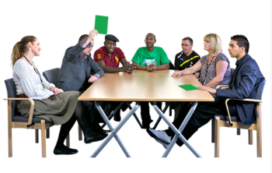 | - Keep in touch  - Real meetings  - Social media such as Facebook, Twitter  - Upload films  - Online contact important for parents and carers who do not have time to come to meetings  - Website can feel safer for sharing views and experiences  - Central point for nformation to stop the overload
- Things to do
- Address general issues and also specific issues – e.g. for people who cannot speak
- Work and train other employment programmes
- Standardise what good looks like
- See paper to Simon Stevens from CBF, Mencap and families

- Feedback is very important
- Feedback and update
- Specific feedback on actions and outcomes is crucial!!
- Get good at feedback
- Need to know who to contact with their concerns

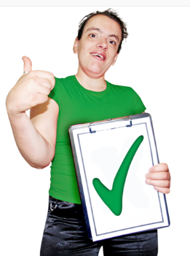 | - It is important that we do this and get it right  - We believe we can do this  - We are all willing and want this to work

What might the challenges be?

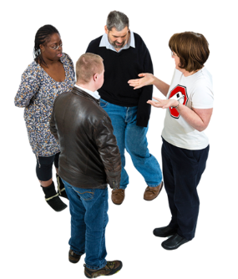 | 1) Communication  - Decision makers need to listen  - Everyone needs to know what is going on  - Do not use jargon  - Be careful how we use words so that we make sure everyone understands what we mean
2) Time and Money
- Funding for self-advocacy groups
- Projects and time costs
- Local groups need incentives to participate
- Co-production takes time
- We need to invest time and money to get it right

3) Working together and not competing

- Competition and arguing
- Local versus national
- Not competing voices

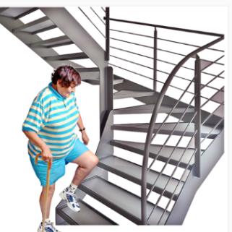 | 4) Build on what is there  - Don’t reinvent wheels  - Learn from what did not work from other networks  - Use the voices of existing groups

Next steps
What we will do | Why we will do it | When
We will go out and talk to existing Learning Disability networks, groups and forums. We will talk about how we can work together. | We will talk to existing networks, groups and forums because we want to work together as one big team. We do not want to have lots of people working separately to achieve the same goal.  If we work together we can learn from other people what worked well for them. We can continue to work on things that worked well instead of starting something new. | This is on-going work that we will begin in Summer 2015
We will have face to face meetings that bring people together. We will have these meetings as well as having an online network of people. | It is important that we have lots of different ways to talk to people. Face to face meetings are important for people who do not use the internet or social media. | We hope first meeting will happen autumn 2015
We will explore the use of virtual networks so that everyone can keep up to date with our work and our progress.  We could also explore the use of films so that people can share their thoughts and experiences with us. | We want all the networks in the country to communicate better so we can instantly share thoughts and ideas.  This means that people will not have to wait for an actual meeting to feedback on ideas.  An online network is good for people who do not have time to come to our meetings. | We have started to explore in the summer 2015 and hope to develop something by Autumn/Winter
The Learning Disability Engagement team is meeting up with other teams in NHS England and also other public sector partners e.g. Department of Health, Care Quality Commission and Health Education England. They will talk about how to meaningfully engage with people with a learning disability and/or autism, and their families and carers. | The Learning Disability Engagement team are not the only people who want to talk to you.  We need to make sure the health care system works together to engage people in a sensible way. You should only have to ‘tell your story once’. | This is on-going work that we will begin in Summer 2015
We will feedback to you what we will do and what we have done.  We have set up an email address for you to contact if you have any questions or suggestions for us. It is LDengage@nhs.net | Feedback is very important. Telling you what we have done and what we are going to do means you are informed about our work. If you are informed you can take part in our discussions. | We will continually feedback to you
We will find a way of producing information in a way that is accessible and useful.  It will be the same across the whole of NHS England. | NHS England will usually pay someone to make an easy read version of a final report. We need to find a way to communicate all of our information well ourselves.  We need to co-produce this work with you because different groups think that different types of easy read are good. | We need to co-produce this work by Summer 2016 (before the Accessible Information Standard is a legal requirement in July 2016).
We will talk to the network about setting up “a co-production group” | We will need to meet and hear from experts by experience to discuss some important pieces of work. It is important that we work together and hear your views. | At the first network meeting – Autumn 2015
We will turn our expenses policy into easy read.  The expenses policy is a document that explains what money you can claim back from NHS England if you have voluntarily attended an event or meeting of ours. | The expenses policy needs to be in easy read so that is accessible for anyone to read and use.  It is important that this document is accessible because we need to be clear about when we can pay people for their time and their costs. For example it will say when we can pay for someone the train cost of travelling to a meeting. | Publish Autumn 2015

If you would like a copy of this document in an alternative format, for example braille, please contact us by email LDengage@nhs.net or telephone 0113 825 3279.

