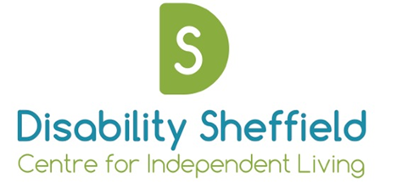

Disability Sheffield Centre for Independent Living
Annual General Meeting

Notice is hereby given that an Annual General Meeting will be held
10am on Thursday 1st December, 2016
At Virgin Lounge, Fargate Sheffield S1 2HE

10-11.15am
- Coffee and Cakes

- Visual presentation of work over the past year

11.15am Formal meeting

  - Opening Remarks - Kate Whittaker, Acting Chair

  - Apologies

  - Approval of 2015 AGM minutes

  - Election of Trustees

  - Presentation of 2015/16 Accounts and appointment of independent examiner

  - Brief overview of year – Emily Morton, Chief Executive

11.45am Close

