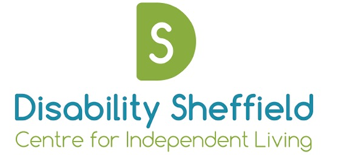

Disability Sheffield Centre for Independent Living
Annual General Meeting

Draft Minutes

On: Friday 19th November 2021 at 2.45 – 3.30pm

At: Remote via Zoom

Trustees
John Fuller, Matt Gibson, Darren Lee, Natalie Yarrow, Adam Butcher, Brian Hodges, Kate Whittaker, Grahame Whitfield, Christine Griffiths,

Staff and members
Emily Morton, Rosemary Hill

Apologies
Zanib Malik

Welcome and Opening Remarks
Darren Lee, Chair. Opened the meeting and thanked everyone for attending.

Approval of minutes from the AGM on Dec 2019:
Approval of 2020 AGM minutes – approved with amendment to refer to Darren Lee not Probets. Proposed by Darren and seconded by Matt.

Appointment of trustees
Everyone was reappointed to the Board on mass. This was formally agreed.

Presentation of 2020/21 Accounts
Matt Gibson, treasurer presented the accounts. The accounts were previously discussed and approved by the board of trustees at their Board meeting on 19th November 2021. Matt Gibson proposed that the meeting adopt the annual accounts presented, Adam Butcher seconded, all approved

Appointment of independent examiner
It was proposed that we would continue to use Voluntary Action Sheffield as our independent examiner for 2021/2022. The continuation of Voluntary Action Sheffield as our Independent Examiner was proposed by Matt Gibson and seconded by Brian Hodges, all approved

Brief Overview of Year
Emily Morton, Chief Executive gave a brief overview of the past year and encouraged people to read the summary of projects and past work outlined in the 2019/20 Annual Accounts.

Staff and volunteers have been fantastic in being so flexible and responding to challenges of covid. We have grown this year, volunteer base has grown quite a bit.

One of things we need to look at is how we consolidate this growth. For example over 50 people regularly involved with Sheffield Voices. Amazing peer advocacy going on. We need to review and set up internal structures to make sure support is in place. Plus other work including; advocacy, direct payments work, engagement work, inclusive cycling, healthy living.

Because of the way we have responded around covid we have become much more publicly visible, more disabled people know about us, more contact with other organisations wanting advice or to engage with that. Brings its own challenges but a good problem to have.

Need to keep ourselves sustainable but continue to develop in a positive way.
All trustees wanted to give a massive thanks to Emily and all the staff and volunteers.

Closing Remarks
Darren Lee, Chair ended the meeting and thanked everyone for attending

