September 2016: Advocacy Project: North of England
Gaining Client, Family and Advocacy Providers Views on Advocacy Services: Successes, Challenges and Gaps

You may have been sent this because you chair or facilitate a client and family group for people with a learning disability and or autism.

NHS England in the North is undertaking a project to understand the provision of advocacy services for adults with a learning disability and or autism across the North of England, including successes, challenges and gaps.

The project is currently divided into three phases:
1) Understanding the Baseline
2) Standards for Advocacy
3) A Quality Check for Advocacy.

For further information you may like to read the narrative for the project which is enclosed with this document.

For clarity we have defined advocacy as follows:
Advocacy is about hearing the voice of an individual, advocacy supports the person to speak up on issues or decisions, the advocate might speak on behalf of the person.
Adapted from VoiceAbility (2016)
We are using two terms within this project to describe advocacy services:
1) Formal: Paid statutory advocacy, such as Independent Mental Health Advocacy (IMHA), Independent Mental Capacity Act Advocacy (IMCA) and Independent advocacy commissioned under the Care ACT 2014.
2) Informal: Family, peer, self, and group are forms of informal advocacy, some forms of informal advocacy may receive funding to support their work.

Gaining Client and Family views on Advocacy
- We would like to gain client/ family and advocacy providers views on advocacy
- We may be able to attend some local meetings or groups but not all
- We have developed an easy read questionnaire to help gain views from client and families or from advocacy service providers
- Can chairs or facilitators of any groups where clients and families attend be informed of the project, and be encouraged to support gaining views through the use of the questionnaire
- We request that views collected are collated into one document prior to returning by email. The easy read template can be used to both gather and collate views.
- Please return completed questionnaires to Sally Brown on the email below, please indicate which geographical areas (Clinical Commissioning Group, Local Authority for example) the views have been obtained from
- If you would like to discuss further please contact Sally Brown on the email below

Case Studies
- As part of the wider advocacy project we are also interested in obtaining some short case studies/stories/practice examples where things have been successful or challenging in terms of advocacy services,
- There is an easy read template for stories/ case studies, please ask for it if you were not emailed a copy
- Case studies do not need to be pages of text but just a paragraph or so.
- Case studies will support sharing and learning across the North of England in relation to advocacy.

By end October 2016. Please return completed questionnaire and case studies to: Sally Brown at: sally@brownsally.co.uk

EASY READ Questionnaire: Advocacy
(Please return completed questionnaires to Sally Brown sally@brownsally.co.uk by end October 2016)

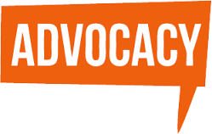 | - NHS England in the North of England are undertaking a project to look at Advocacy
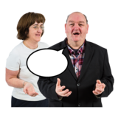 | - An advocate is someone who helps you to speak up about issues that are important to you, they may speak on your behalf  - Some advocates are paid to work with you (for example if you are detained under the Mental Health Act)
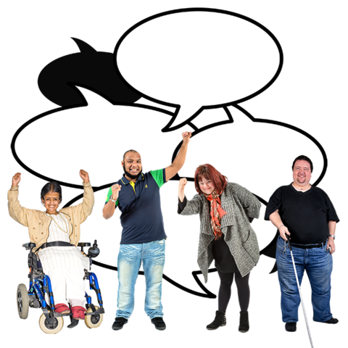 | - Some advocates are volunteers and may have a learning disability and/or autism themselves  - Sometimes advocacy is delivered in groups
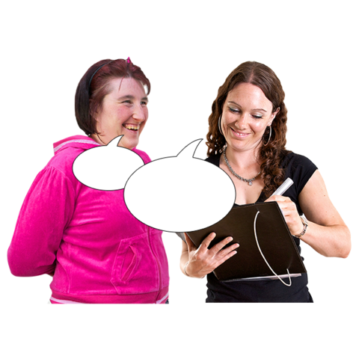 | - We would like your views on advocacy services to help us inform the project

Advocacy Questions

This questionnaire is about advocacy: The support you get, or don’t get, to help
you speak up about issues or decisions which are important to you.

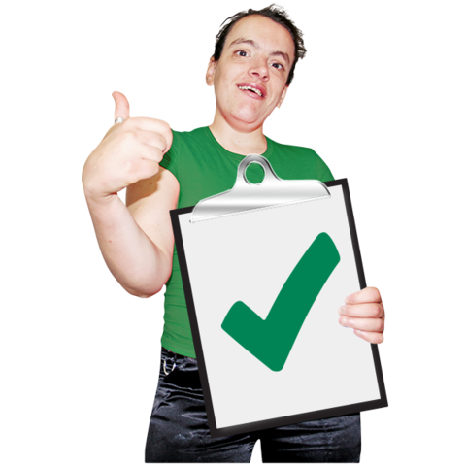 What works well? | What does not work so well?

What could be improved (be better)? | Is there anything else about being supported to speak up, you would like to tell us about?

